# **Motivations**

## **Non Linear Hypothesis**

* This is a super-vised Learning classification problem.
* Applying Logistic Regression to this problem.  
  By applying we got a hypothesis that separates positive and negative examples.
* This idea works well only for two features x1 and x2.

But in building a ML model, we require still more features to get better and accurate results.

There are 100 different features to predict the house price.  
So for this what will happen we include all the quadratic terms.

Quadratic features

Including all the quadratic features over-fits the data and computationally expensive.  
So we can include only a subset of features.

Including only the above features doesn’t capture very complex hypothesis.  
It will result in a circle which is totally in-evident.

Cubic features

Need for a Non-Linear Hypothesis

Lets put all the pixel values and their corresponding type (i.e cars/non cars)

## **Quiz**  


So, simple logistic regression together with adding in maybe the quadratic or the cubic features - that's just not a good way to learn complex nonlinear hypotheses when n is large because you just end up with too many features.

## **Neurons and the Brain**

### **Neuro Re-wiring Experiments**

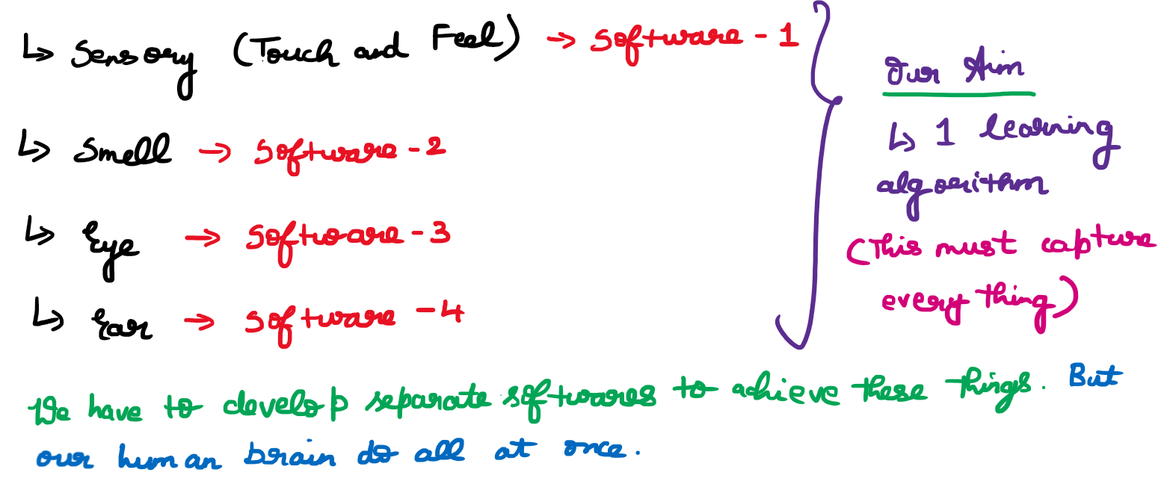

And instead of needing to implement a thousand different programs or a thousand different algorithms to do, you know, the thousand wonderful things that the brain does, maybe what we need to do is figure out some approximation or to whatever the brain's learning algorithm is and implement that and that the brain learned by itself how to process these different types of data.

So that each pixel gets mapped to a location on your tongue where maybe a high voltage corresponds to a dark pixel and a low voltage corresponds to a bright pixel and, even as it does today, with this sort of system you and I will be able to learn to see, you know, in tens of minutes with our tongues.

The blind people can clap their hands, so that the sound reaches and bounce back from the objects that is in front of them. In this way they will able to identify which is object is in front of them.

Third example is the Haptic Belt where if you have a strap around your waist, ring up buzzers and always have the northmost one buzzing. You can give a human a direction sense similar to maybe how birds can, you know, sense where north is. it's pretty amazing to what extent is as if you can plug in almost any sensor to the brain and the brain's learning algorithm will just figure out how to learn from that data and deal with that data.

***it's pretty amazing to what extent is as if you can plug in almost any sensor to the brain and the brain's learning algorithm will just figure out how to learn from that data and deal with that data.***

And there's a sense that if we can figure out what the brain's learning algorithm is, and, you know, implement it or implement some approximation to that algorithm on a computer, maybe that would be our best shot.

The above diagram represents a single neuron.  
Another example

# **Neural Networks**

## **Model Representation-1**

## **Model Representation-2**

# **Applications**

# **Review**